# Install STAF on macOS

By [qzh.anny@gmail.com](mailto:qzh.anny@gmail.com)

## Download latest STAF binary for macOS from <http://staf.sourceforge.net/getcurrent.php>.

In my PC, I installed with STAF3426-setup-macosx-universal.bin

## Start staf installation wizard by running

$ sudo ./STAF3426-setup-macosx-universal.bin

Preparing to install

Extracting the installation resources from the installer archive...

Configuring the installer for this system's environment...

Launching installer...

Properties file for authenticator not read as user is truly "root"

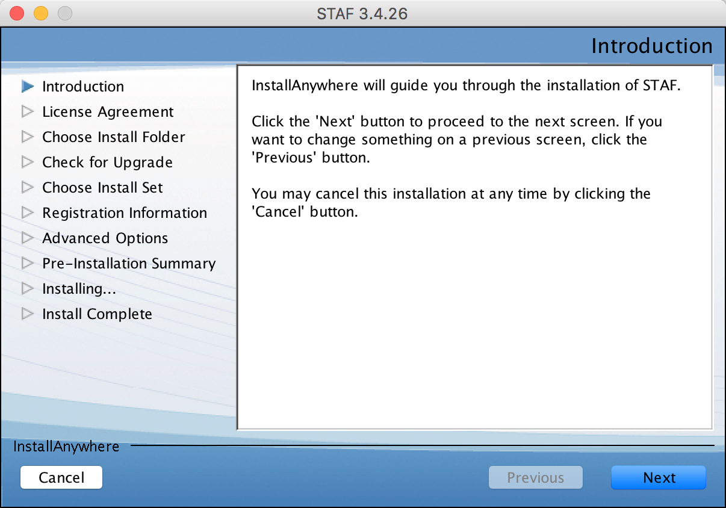

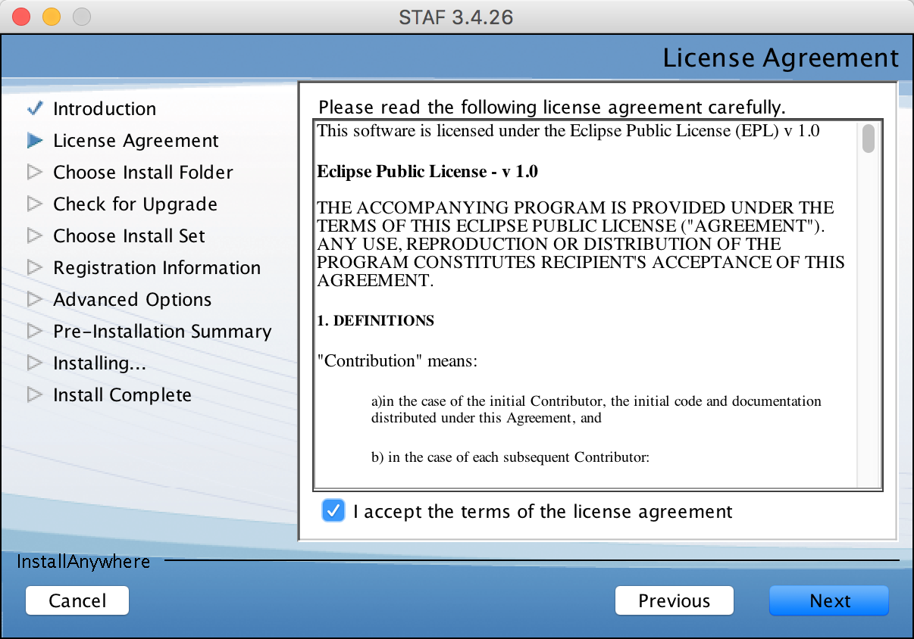

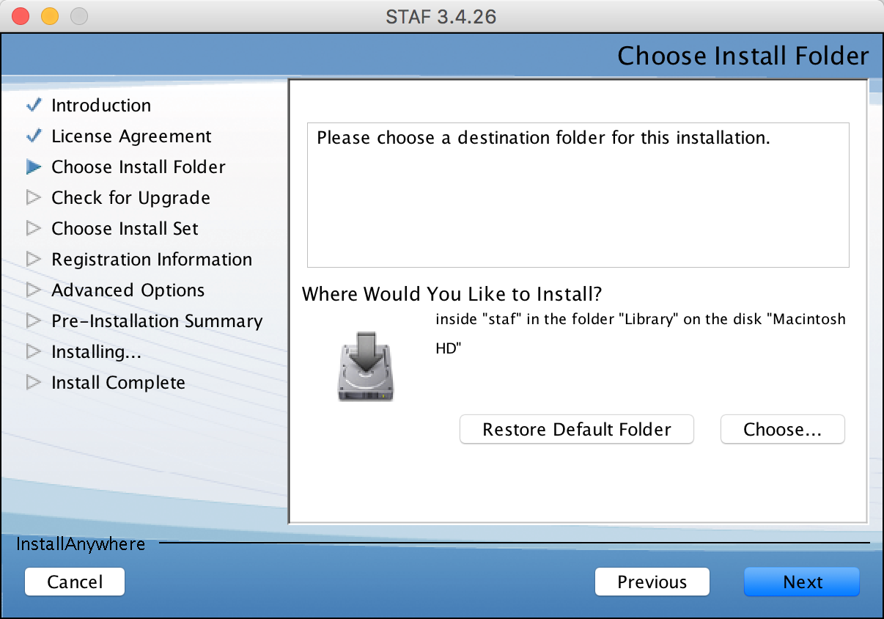

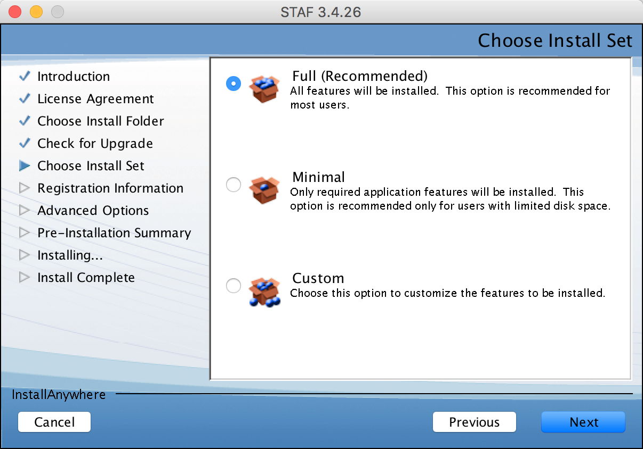

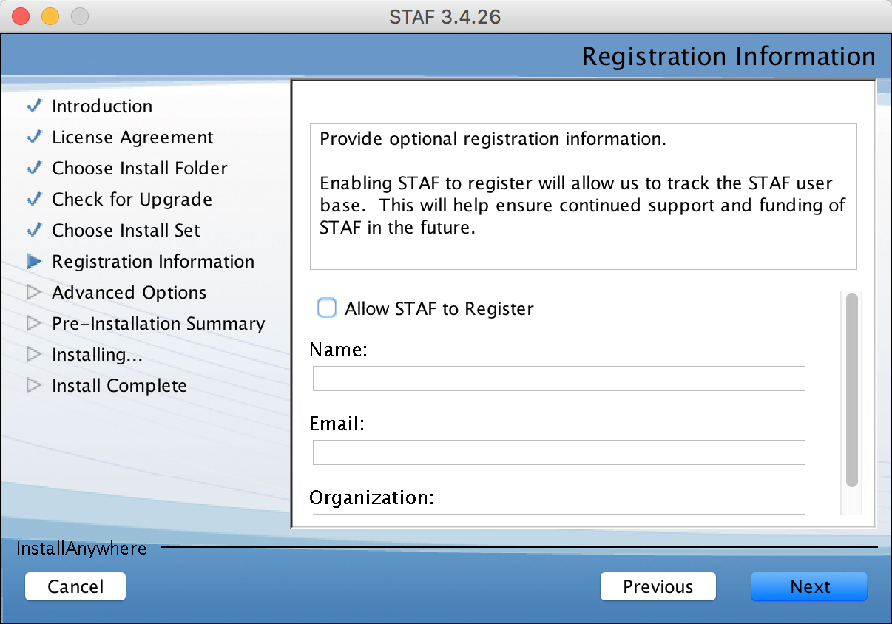

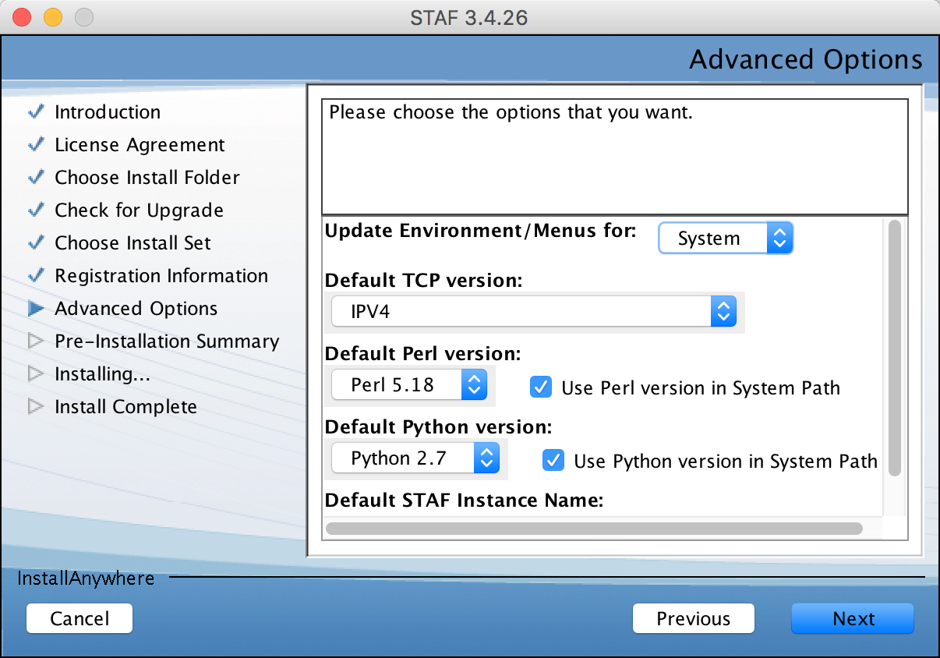

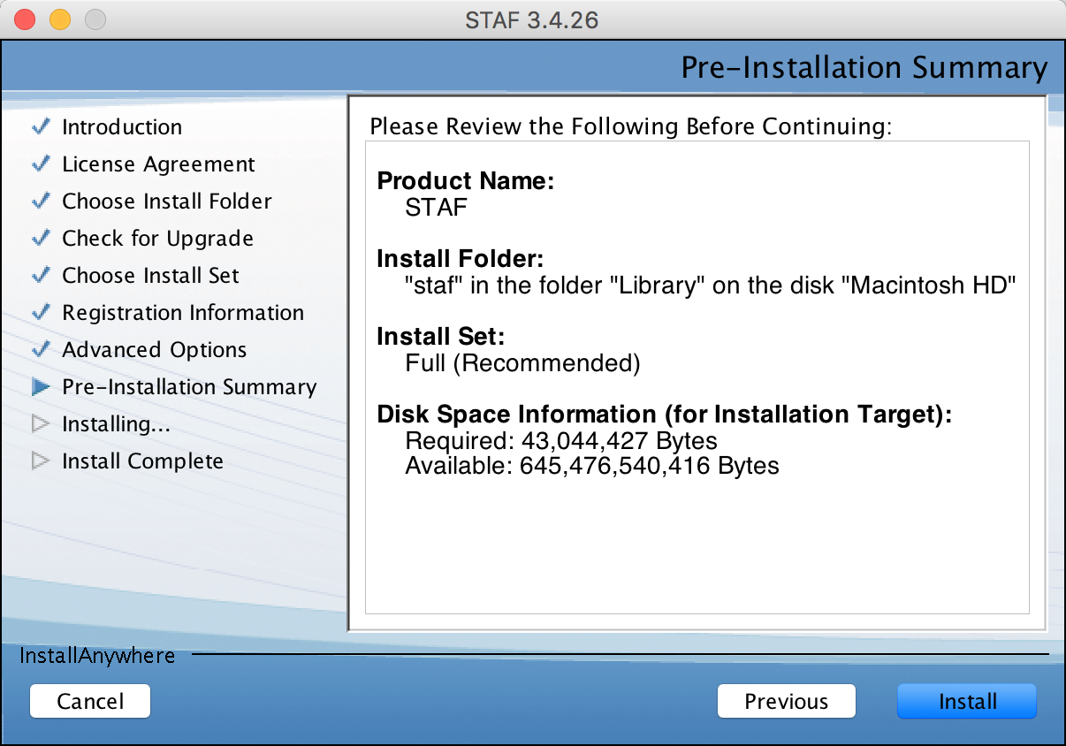

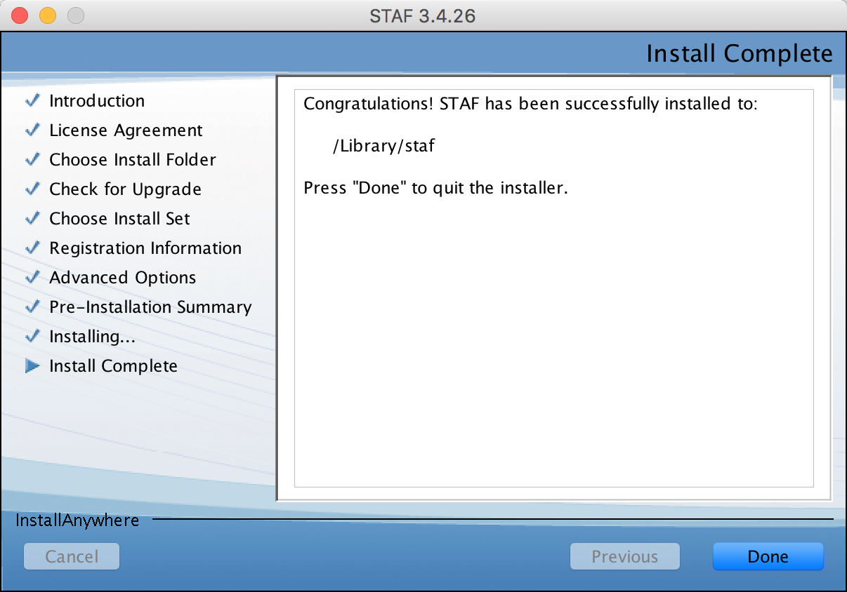

## Create a symbolic link to /Library/staf/lib

$ sudo mkdir -p /Library/staf/lib /opt/dev/autobuild/build/rel/macosx/staf/retail

$ sudo ln -s /Library/staf/lib /opt/dev/autobuild/build/rel/macosx/staf/retail/lib

## Edit /Library/staf/startSTAFProc.sh

$ sudo vim startSTAFProc.sh

#!/bin/sh

# Sets up the STAF environment variables and starts STAFProc

# in the background, logging STAFProc output to nohup.out

ipconfig waitall

. /Library/staf/STAFEnv.sh

cd /Library/staf/lib

nohup /Library/staf/bin/STAFProc &

## Add your ip/hostname to /etc/hosts

your_PC_ip  your_PC_hostname.domain your_PC_hostname

## Create a data diretory

$ sudo mkdir /Library/staf/data

$ sudo chmod -R a+w data

## Change "trust machine local://local level 5" to "trust machine *://* level 5" in /Library/staf/bin/STAF.cfg

$ sudo sed -i -e 's/local:\/\/local /*:\/\/* /' /Library/staf/bin/STAF.cfg

## Start STAFProc

$ /Library/staf/startSTAFProc.sh

## Start STAFProc during boot (not tested)

$ sudo vim /Library/LaunchDaemons/com.ibm.staf.plist

<?xml version="1.0" encoding="UTF-8"?>

<!DOCTYPE plist PUBLIC "-//Apple Computer//DTD PLIST 1.0//EN"

"<http://www.apple.com/DTDs/PropertyList-1.0.dtd>">

<plist version="1.0">

<dict>

<key>Label</key>

<string>com.ibm.staf</string>

<key>Program</key>

<string>/Library/staf/startSTAFProc.sh</string>

<key>RunAtLoad</key>

<true/>

<key>StandardOutPath</key>

<string>/Library/staf/com.ibm.staf.out</string>

<key>StandardErrorPath</key>

<string>/Library/staf/com.ibm.staf.out</string>

</dict>

</plist>

**Notes**: By default, staf is installed under /Library/staf. If you changed the target installation folder, please make sure you also change /Library/staf in above commands to your staf's installation folder.

**Reference**:

<http://staf.sourceforge.net/current/STAFInstall.pdf>